EWMA correlation: AUDUSD and USDCHF
Method 06 / daily log returns / lambda = 0.94 / Alpari D1 full available history

Study setup
Logical pair: AUDUSD , USDCHF
Broker symbols: AUDUSD_i , USDCHF_i
Snapshot: 2026-11-03_majors_alpari_D1
Timeframe: D1
Matched return window: 1999-01-05 to 2026-11-02 (UTC bar dates)
Matched return count n: 7200
Dropped unfinished last bar dated 2026-11-03 UTC after a tick-volume check against the prior complete day.
Lambda: 0.94 (today weight 0.06)
Burn-in ignored in path summaries and chart: first 60 updates
Mean adjustment: each leg demeaned by its mean on the matched rows
Seeds: c_0 = v_x,0 = v_y,0 = 0
Complete matched rows (Excel): AUDUSD-USDCHF_EWMA_D1.xlsx
Complete matched rows (HTML table): AUDUSD-USDCHF_EWMA_D1_data.html

Method carried forward
EWMA correlation updates covariance and variances of mean-adjusted daily log returns of close, ln(close_t / close_t-1), with lambda = 0.94 (6% weight on today's product or square, 94% on yesterday's EWMA state). Quotes are not inverted. Each leg is demeaned by its mean on the matched rows; that mean uses the full sample, so the rho path is a full-sample description, not a live filter. Seeds start at zero. Path summaries and the chart ignore the first 60 updates so the zero seed has faded. The headline is rho on the last day. rho is symmetric under swap of the two symbols. A high |rho| does not prove cause, lead-lag, or a trading signal. Today's return sits inside today's rho, so the estimate can only inform a later decision. Same-sample Pearson r is a side check only.

Results
Latest EWMA rho: 0.135132
Post-burn-in path (n=7140): mean=-0.441226, median=-0.472604, min=-0.880285, max=0.482792, std=0.230293
Share of post-burn-in days with |rho| >= 0.4: 61.20%; |rho| >= 0.7: 11.48%
Same-sample Pearson r: -0.380878
Latest rho minus r: 0.516011

Conclusion
Over 7200 matched daily log-return rows for AUDUSD and USDCHF (broker quote directions unchanged), latest EWMA rho with lambda=0.94 is 0.1351 (positive, weak recent linear link in this sample). After a 60-day burn-in, path mean is -0.4412, std is 0.2303, and the range is [-0.8803, 0.4828]. Same-sample Pearson r is -0.3809 (latest rho minus r = 0.5160). This does not establish cause, lead-lag, or a lasting trading rule.

Charts
Daily closes

Daily log returns
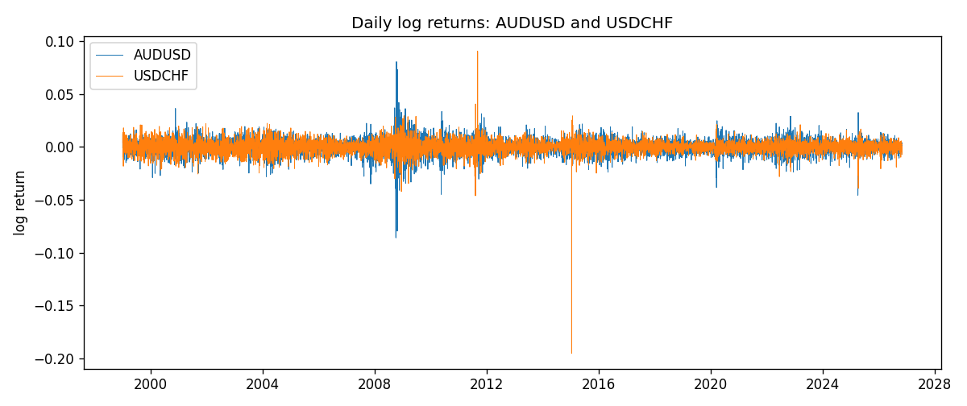
EWMA rho path with Pearson r reference
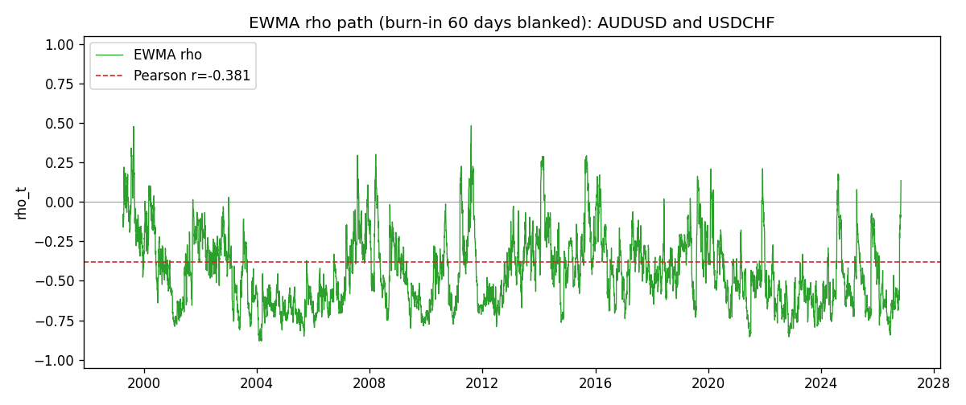

Data report
Every matched row that entered the EWMA recursion is stored in the sibling Excel workbook named AUDUSD-USDCHF_EWMA_D1.xlsx. That file is the complete data archive for redrawing charts. Embedding all rows as a Word table is impractical at this length; the Word file holds the column list, column summaries, and the first and last 15 matched rows.
Columns: time, AUDUSD_open, USDCHF_open, AUDUSD_high, USDCHF_high, AUDUSD_low, USDCHF_low, AUDUSD_close, USDCHF_close, AUDUSD_tick_volume, USDCHF_tick_volume, AUDUSD_spread, USDCHF_spread, AUDUSD_real_volume, USDCHF_real_volume, AUDUSD_log_return, USDCHF_log_return, AUDUSD_x_demeaned, USDCHF_y_demeaned, c_t, v_x, v_y, rho_t
Column summaries (matched calculation rows)
column | count | mean | std | min | 25% | 50% | 75% | max
AUDUSD_open | 7200 | 0.7519587 | 0.13528421 | 0.4785 | 0.6610975 | 0.731415 | 0.8091275 | 1.10284
USDCHF_open | 7200 | 1.0982244 | 0.25258622 | 0.72022 | 0.920675 | 0.990175 | 1.238625 | 1.8219
AUDUSD_high | 7200 | 0.75601148 | 0.13584385 | 0.4878 | 0.6647 | 0.734785 | 0.8152525 | 1.10795
USDCHF_high | 7200 | 1.1035234 | 0.25433538 | 0.73305 | 0.9249475 | 0.99377 | 1.2436 | 1.8313
AUDUSD_low | 7200 | 0.74790307 | 0.1345988 | 0.4775 | 0.65778 | 0.727495 | 0.804225 | 1.0975
USDCHF_low | 7200 | 1.0930985 | 0.25099871 | 0.08565 | 0.917415 | 0.98668 | 1.232725 | 1.8121
AUDUSD_close | 7200 | 0.75201172 | 0.13526687 | 0.4786 | 0.6612 | 0.731695 | 0.8091975 | 1.10169
USDCHF_close | 7200 | 1.0982149 | 0.25248642 | 0.72025 | 0.92097 | 0.990145 | 1.238625 | 1.8217
AUDUSD_tick_volume | 7200 | 77358.386 | 138142.18 | 109 | 5440 | 43334.5 | 71332.25 | 1234623
USDCHF_tick_volume | 7200 | 74199.562 | 113414.45 | 350 | 12776 | 40195 | 70261.25 | 858589
AUDUSD_spread | 7200 | 30.817222 | 16.887144 | 0 | 13 | 30 | 50 | 50
USDCHF_spread | 7200 | 26.104306 | 24.710129 | 0 | 5 | 16 | 50 | 100
AUDUSD_real_volume | 7200 | 5.2428187e+09 | 1.2538918e+11 | 0 | 0 | 0 | 0 | 3.811512e+12
USDCHF_real_volume | 7200 | 2.3239785e+10 | 8.9047261e+10 | 0 | 0 | 0 | 0 | 1.9331921e+12
AUDUSD_log_return | 7200 | 2.837e-05 | 0.00754598 | -0.08602525 | -0.00385535 | 0.0002835 | 0.00415437 | 0.0806166
USDCHF_log_return | 7200 | -7.168e-05 | 0.00659376 | -0.19545699 | -0.00336083 | 8.057e-05 | 0.00331954 | 0.09051364
AUDUSD_x_demeaned | 7200 | 0 | 0.00754598 | -0.08605363 | -0.00388372 | 0.00025512 | 0.004126 | 0.08058822
USDCHF_y_demeaned | 7200 | -0 | 0.00659376 | -0.19538531 | -0.00328915 | 0.00015225 | 0.00339122 | 0.09058532
c_t | 7200 | -1.895e-05 | 1.902e-05 | -0.00017382 | -2.562e-05 | -1.392e-05 | -7.77e-06 | 5.563e-05
v_x | 7200 | 5.69e-05 | 0.00010022 | 4e-08 | 2.62e-05 | 3.684e-05 | 5.888e-05 | 0.00173318
v_y | 7200 | 4.344e-05 | 9.013e-05 | 9.7e-07 | 1.841e-05 | 2.971e-05 | 4.756e-05 | 0.00231278
rho_t | 7200 | -0.43538188 | 0.23904336 | -1 | -0.62118256 | -0.47071976 | -0.2870536 | 0.94091466
First 15 matched rows (selected columns)
time | AUDUSD_close | USDCHF_close | AUDUSD_log_return | USDCHF_log_return | AUDUSD_x_demeaned | USDCHF_y_demeaned | c_t | v_x | v_y | rho_t
1999-01-05 | 0.6215 | 1.3724 | -0.00080418179 | 0.0039424743 | -0.0008325543 | 0.0040141493 | -2.0051984e-07 | 4.15888e-08 | 9.6680367e-07 | -1
1999-01-06 | 0.6289 | 1.3912 | 0.011836351 | 0.013605652 | 0.011807978 | 0.013677327 | 9.5016061e-06 | 8.4047943e-06 | 1.2132952e-05 | 0.94091466
1999-01-07 | 0.6345 | 1.3782 | 0.0088650256 | -0.0093883841 | 0.0088366531 | -0.0093167091 | 3.9917981e-06 | 1.2585693e-05 | 1.6613039e-05 | 0.27606126
1999-01-08 | 0.6347 | 1.3935 | 0.00031515916 | 0.011040268 | 0.00028678664 | 0.011111943 | 3.9434956e-06 | 1.1835486e-05 | 2.3024773e-05 | 0.23888596
1999-01-11 | 0.6393 | 1.4009 | 0.0072213815 | 0.0052963193 | 0.0071930089 | 0.0053679943 | 6.0236078e-06 | 1.422972e-05 | 2.3372209e-05 | 0.33030005
1999-01-12 | 0.6362 | 1.3872 | -0.0048608485 | -0.0098275602 | -0.004889221 | -0.0097558852 | 8.524112e-06 | 1.4810205e-05 | 2.7680514e-05 | 0.42099945
1999-01-13 | 0.6312 | 1.3621 | -0.0078902098 | -0.018259701 | -0.0079185823 | -0.018188026 | 1.6654068e-05 | 1.768383e-05 | 4.5867939e-05 | 0.58475986
1999-01-14 | 0.6295 | 1.3588 | -0.002696916 | -0.0024256692 | -0.0027252886 | -0.0023539941 | 1.6039743e-05 | 1.7068432e-05 | 4.344834e-05 | 0.58899823
1999-01-15 | 0.634 | 1.3834 | 0.007123101 | 0.01794228 | 0.0070947284 | 0.018013955 | 2.2745605e-05 | 1.9064436e-05 | 6.0311594e-05 | 0.67078773
1999-01-18 | 0.6346 | 1.379 | 0.00094592471 | -0.0031856384 | 0.0009175522 | -0.0031139634 | 2.1209435e-05 | 1.7971084e-05 | 5.7274705e-05 | 0.66108993
1999-01-19 | 0.6392 | 1.3789 | 0.0072225153 | -7.2518946e-05 | 0.0071941428 | -8.439258e-07 | 1.9936505e-05 | 1.9998161e-05 | 5.3838222e-05 | 0.60758724
1999-01-20 | 0.64 | 1.3889 | 0.0012507819 | 0.0072259871 | 0.0012224094 | 0.0072976621 | 1.9275559e-05 | 1.8887928e-05 | 5.3803281e-05 | 0.60465887
1999-01-21 | 0.6405 | 1.3836 | 0.00078094498 | -0.0038232689 | 0.00075257247 | -0.0037515938 | 1.7949624e-05 | 1.7788634e-05 | 5.1419552e-05 | 0.5934989
1999-01-22 | 0.6327 | 1.3834 | -0.012252745 | -0.0001445609 | -0.012281118 | -7.2885877e-05 | 1.6926354e-05 | 2.5770867e-05 | 4.8334698e-05 | 0.47958921
1999-01-25 | 0.6302 | 1.3868 | -0.0039591468 | 0.0024546976 | -0.0039875193 | 0.0025263727 | 1.5306335e-05 | 2.5178634e-05 | 4.5817569e-05 | 0.45064973
Last 15 matched rows (selected columns)
time | AUDUSD_close | USDCHF_close | AUDUSD_log_return | USDCHF_log_return | AUDUSD_x_demeaned | USDCHF_y_demeaned | c_t | v_x | v_y | rho_t
2026-10-13 | 0.69821 | 0.83244 | 0.0035007712 | -0.0024955621 | 0.0034723986 | -0.0024238871 | -8.4548009e-06 | 1.4138773e-05 | 1.329715e-05 | -0.61662091
2026-10-14 | 0.69715 | 0.83489 | -0.0015193215 | 0.0029388325 | -0.001547694 | 0.0030105075 | -8.2270735e-06 | 1.3434168e-05 | 1.304311e-05 | -0.62151185
2026-10-15 | 0.69191 | 0.82676 | -0.0075447063 | -0.0097855323 | -0.0075730788 | -0.0097138573 | -3.3196207e-06 | 1.6069209e-05 | 1.7922065e-05 | -0.19561276
2026-10-16 | 0.69426 | 0.82377 | 0.0033906408 | -0.0036230826 | 0.0033622682 | -0.0035514076 | -3.8368906e-06 | 1.5783348e-05 | 1.7603491e-05 | -0.23018682
2026-10-19 | 0.6978 | 0.82677 | 0.0050859986 | 0.0036351779 | 0.0050576261 | 0.003706853 | -2.4818045e-06 | 1.6371122e-05 | 1.7371727e-05 | -0.14716579
2026-10-20 | 0.70022 | 0.8246 | 0.0034620426 | -0.0026281224 | 0.0034336701 | -0.0025564474 | -2.8595761e-06 | 1.609626e-05 | 1.6721549e-05 | -0.17430142
2026-10-21 | 0.70275 | 0.82427 | 0.0036066384 | -0.00040027413 | 0.0035782659 | -0.00032859911 | -2.7585504e-06 | 1.5898723e-05 | 1.5724734e-05 | -0.17446493
2026-10-22 | 0.70186 | 0.82032 | -0.0012672558 | -0.0048036381 | -0.0012956284 | -0.0047319631 | -2.2251855e-06 | 1.5045519e-05 | 1.6124739e-05 | -0.14286185
2026-10-23 | 0.70353 | 0.82497 | 0.0023765656 | 0.005652514 | 0.0023481931 | 0.005724189 | -1.2851843e-06 | 1.4473629e-05 | 1.7123235e-05 | -0.081636388
2026-10-26 | 0.70128 | 0.82649 | -0.0032032829 | 0.0018407959 | -0.0032316554 | 0.001912471 | -1.5789e-06 | 1.4231827e-05 | 1.6315293e-05 | -0.10361601
2026-10-27 | 0.70245 | 0.82865 | 0.0016669876 | 0.0026100526 | 0.0016386151 | 0.0026817276 | -1.2205069e-06 | 1.3539021e-05 | 1.5767876e-05 | -0.083533371
2026-10-28 | 0.70533 | 0.82781 | 0.0040915541 | -0.0010142111 | 0.0040631816 | -0.0009425361 | -1.3770582e-06 | 1.3717246e-05 | 1.4875106e-05 | -0.09640261
2026-10-29 | 0.70245 | 0.82379 | -0.0040915541 | -0.0048680164 | -0.0041199266 | -0.0047963414 | -1.0880021e-07 | 1.3912639e-05 | 1.5362893e-05 | -0.0074419799
2026-10-30 | 0.70316 | 0.82438 | 0.0010102376 | 0.00071594559 | 0.00098186512 | 0.00078762061 | -5.5871969e-08 | 1.3135724e-05 | 1.447834e-05 | -0.0040514229
2026-11-02 | 0.69971 | 0.81851 | -0.0049184984 | -0.0071459744 | -0.004946871 | -0.0070742994 | 2.0472191e-06 | 1.3815873e-05 | 1.6612382e-05 | 0.13513231

